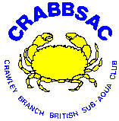
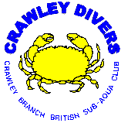
Crawley BS-AC
Dive Marshal Kit
Reference Material 2

Contents

Page
1 | Contents
3 | Marshalling dives where different breathing gas mixes are used
4 | Rebreather Safe Diving Practices
9 | Mixed Gas Safe Diving Practices
11 | Maximum Operating Depths
12 | Equivalent Air Depths
13 | Oxygen Partial Pressures
14 | CNS O2 Clock Tracking
15 | UPTD Tracking
16 | CND Repetitive Table
17 | Dive Time vs Toxicity Clock Balancing
18 | Nitrox Mixing Tables – Top-up Tables
20 | Nitrox Mixing Tables – From-empty Tables
23 | BSAC Safe Diving Practices

